



Finance Risk & Audit Committee

Independent Member 2025

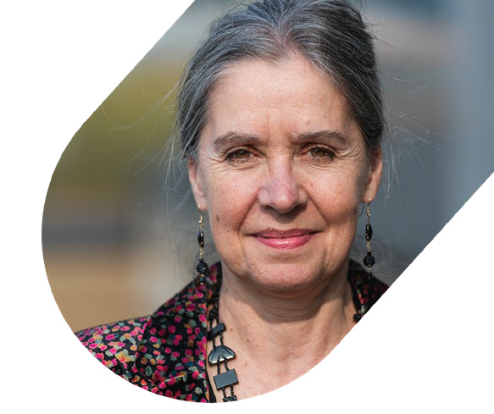

**UND R A BETTER CHILDHOOD**

# 

# Introduction: Message from NCB’s Chair

For 60 years we’ve given a voice to children, young people and their families across the UK. But despite all the progress we’ve made, the challenges we face today are as deep and wide as at any point in our history.

Having a Board with a broad range of skill sets, experience and enormous commitment to NCB has undoubtedly helped NCB to remain in a strong position to continue to deliver our mission with an enhanced strategy. The Board leads by example to ensure that our behaviours, based on trust, openness and respect, set the tone for our organisational culture and that NCB’s values and principles drive all that we do.

To support the Board there are two standing sub-committees: The Finance, Risk and Audit Committee (FRAC) and the People and Culture Committee (PCC), each with membership of appointed Trustees and Independent Members. We are looking for the right people to join our Finance, Risk and Audit Committee as Independent Members.

Our Independent Members complement the legal responsibilities of Trustees and their place is equally valued. They bring advice, support and challenge and their voice is heard. The role of an Independent Member is as fulfilling as that of a Trustee and can be a superb first step into charity governance and Boards for those without prior experience.

As part of our Board development programme, we will provide our Independent Members with comprehensive induction and ongoing support and opportunities to grow in the role.

The FRAC is a dynamic committee, with its broad remit covering finance, risk and both internal and external audit. NCB has been through a period of rapid growth culminating in the 70 staff of Research in Practice joining the NCB family in 2024. An area of focus for the Committee is the need to ensure procedures and controls are commensurate to the larger organisation.

I hope you will enjoy reading more in these pages about NCB, its values, mission, and our extensive work across the children’s and young people sector. I hope that you will feel inspired to join us and be part of making a difference for children.

As Chair of the Board of Trustees I have always felt welcomed, appreciated and supported by my fellow Board members, NCB’s executive and staff across the organisation. If you join us, I know that you would feel the same!

2

**Alison O’Sullivan**

Chair

3

**About us**

**We bring people and organisations together to drive change in society and deliver a better childhood across the UK.**

**We’re the charity that works collaboratively across the issues affecting children to influence policy and get services working together to deliver a better childhood.**

Since 1963 we have been at the forefront of campaigning for children and young people’s rights.

We were founded by Mia Kellmer Pringle in 1963, amid concerns about the welfare of children

in care. Mia recognised that the way to bring about the best for these children was through co-operation.

She gathered health services, education providers, children’s services – everyone with a stake in their care. Only together could they make things work better.

This approach still defines us today. We identify the most serious issues putting our children

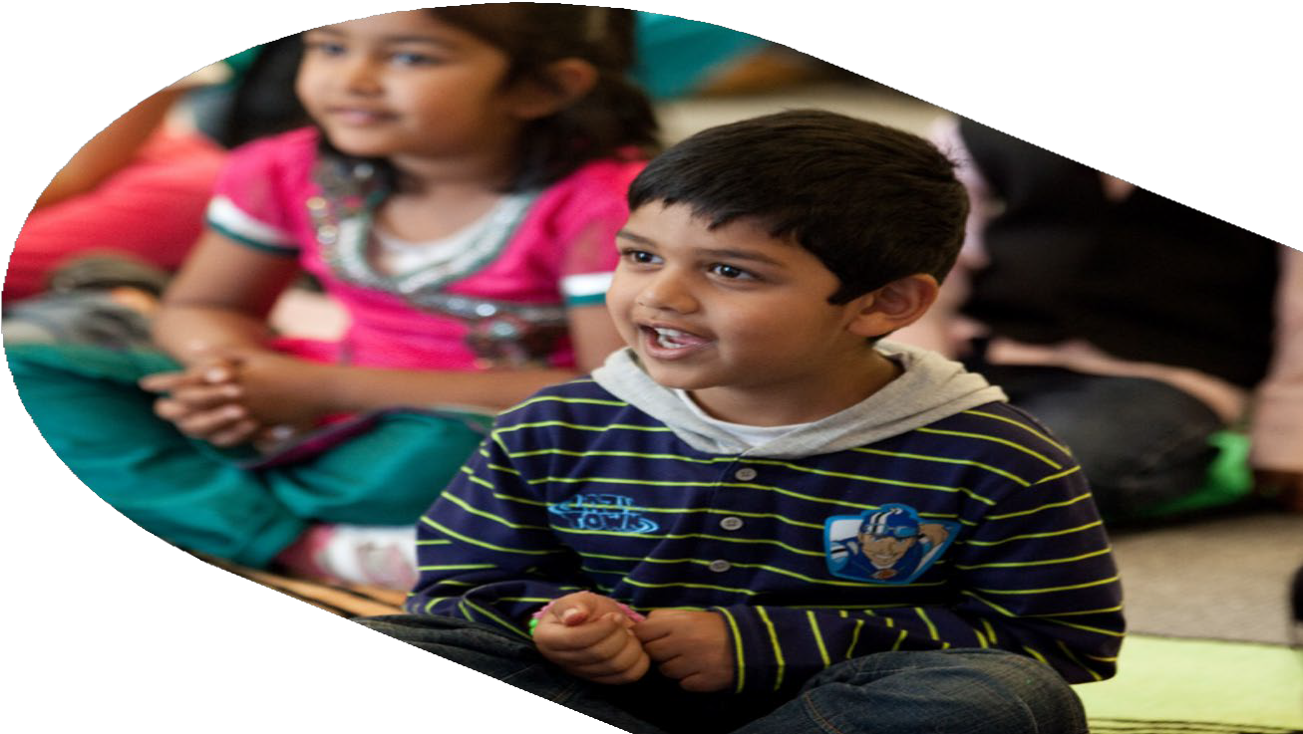

and young people at risk and we bring people and organisations together to drive change in society and deliver a better childhood.

Today, our challenge is greater than ever.

In an age of austerity, we’ve witnessed funding for children’s services cut by half, with a devastating impact on young lives.

In an era of disinformation, trust has never had more value. That’s why it’s so important we’re here to interrogate policy and uncover evidence, taking the voices of children to the

heart of Government to shape better legislation.

Only by working together can we bring about the best for our children.

We’re united for a better start. United for a better future. United for a better childhood.

We’re the National Children’s Bureau.

# NCB Family

Working together to deliver better childhoods. Every member of the NCB family brings people and organisations together to drive change on particular issues and help deliver a better childhood for the UK.



The Anti-Bullying Alliance (ABA) is a

unique coalition of organisations and individuals united against bullying, we’re the national voice for evidence-based practice, delivering varied programme work to end bullying and bring lasting change to children’s lives. We raise awareness of bullying through Anti-Bullying Week each November. We support a network of thousands of schools and colleges and our membership is growing fast in profile and influence.

Read more: [**anti-bullyingalliance.org.uk**](http://councilfordisabledchildren.org.uk/)

We create more opportunities for deeper understanding and practical application when we pair research evidence with wisdom and expertise from people’s own lived experiences. Research in Practice works with and for professionals in the social care, health, criminal justice and higher education sectors offering resources, learning opportunities and specialist expertise to enable people – children, young people, families, adults, carers and communities – to live better lives.

Read more: [**https://www.researchinpractice.org.uk/**](https://www.researchinpractice.org.uk/)

4

The Childhood Bereavement Network (CBN) is the

hub for those working with bereaved children, young people and their families across the UK. We’re here to unite all those supporting bereaved children, young people and their families across the UK. We bring our members together across localities, disciplines and sectors to improve the range and quality of bereavement support for children and increase access to childhood bereavement information guidance and support services.

Read more: [**childhoodbereavementnetwork.org.uk**](http://councilfordisabledchildren.org.uk/)

Our society should respect the rights of disabled children and young people, support them to be active in their communities and allow them to fulfil their potential. The Council for Disabled Children (CDC) brings together professionals, practitioners, policymakers and children and families themselves, to deliver systemic change across education, health and social care.

Read more: [**councilfordisabledchildren.org.uk**](http://councilfordisabledchildren.org.uk/)

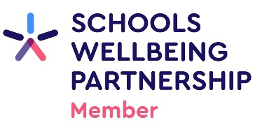

The Schools Wellbeing Partnership is a national network of nearly 50 member organisations that works to improve the wellbeing of all children in education.

Read more: **schoolswellbeing.org.uk**

5

# Our vision, mission and values

## OUR VISION

**For every child to thrive**

## OUR MISSION

**To build a better childhood for every child**

## OUR VALUES

**Our values act as the core beliefs and universal truths that affect how we behave, how we work together as a team, how we structure our internal processes and how we deliver our mission.**

Forever young

* Children and young people are at the heart of what we do. We reflect this energy and optimism in our approach to work.

Better together

* We collaborate from the inside and outside, living up to the trust our partners place in us to do what’s right for children and young people.

Always learning

* Like an inquisitive child, we always ask ‘Why?’, the rigour of our evidence drives our work and helps us challenge ourselves and others not to make assumptions and to search for future progress.

Taking care

* We invest a significant part of our selves in our work. We respect and value that investment by looking after ourselves and each other.

Being brave

* We don’t shy away from the biggest challenges because that’s where children need us most. We speak the truth with the authority of evidence and experience.



6

# Our 2024-29 Strategy:

# United for a better childhood: Building Brighter Futures

Children today face challenges of an unprecedented variety and scale, including discrimination, stretched public services and an explosion in the numbers experiencing mental health issues and life below the poverty line.

For 60 years, the National Children’s Bureau has taken an evidence-informed approach, united individuals and organisations and combined cutting-edge research with the voices of lived experience to drive positive change to improve the complex, interconnected systems that allow every child to thrive.

We are proud of the work NCB has done to push back against these trends, but we must challenge ourselves to go further and do better.

We will deepen and expand our networks in a spirit of openness and collaboration. We will do more to ground our influencing work in our own learning to achieve even more for children. We will continue to listen to and earn the trust of disabled children and their families.

Read more about our 2014–2029 Strategy, United for a Better Childhood: Building Better Futures

[**www.ncb.org.uk/what-we-do/our-strategy**](https://www.ncb.org.uk/what-we-do/our-strategy)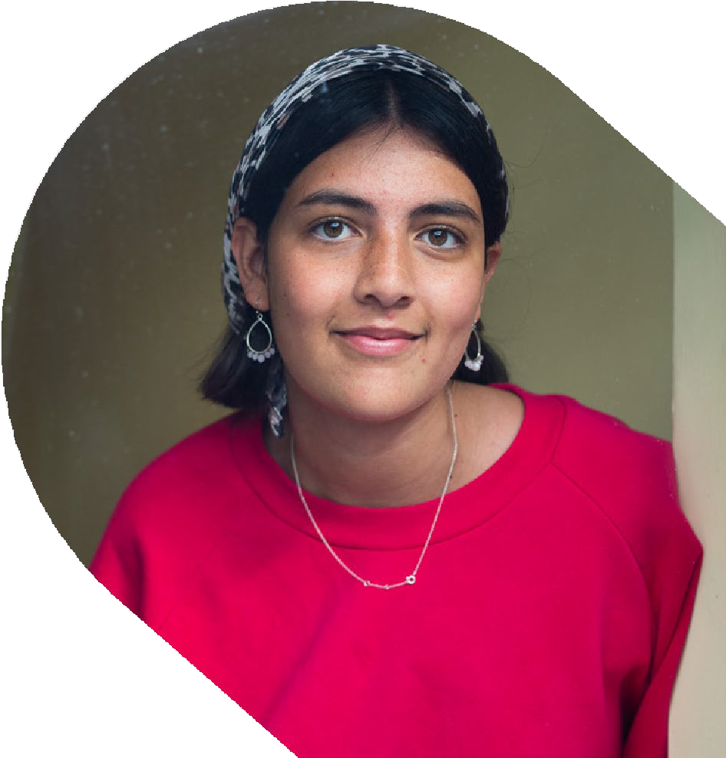

# My Experience as an Independent Member at NCB

I am senior finance professional with experience at CFO level across the Financial Services and Fintech sectors. I am passionate about providing vision and leadership for strategy, change and transformation and have worked in both listed companies and private companies. My voluntary role with NCB has allowed me to use my professional skills and experience to benefit a charity with a mission that resonates strongly with me.

NCB is an organisation of passionate, skilled and committed people governed by a high functioning Board of Trustees. Charity boards benefit hugely from the objective and creative view that an independent member can bring because the viewpoint is fresh and free of the everyday demands that the trustees and staff face; occasionally I am able to provide a light bulb moment and that is wonderful!

Highlights from my six years on the Committee have been helping to guide the organisation through a number of key transitions from closure of the defined benefit pension scheme, through transfer of Research in Practice into NCB last year, increasing annual turnover by c.£5.5m, to the recent development of a robust Risk Assurance Framework.

**Judith Worthy**, Independent Member,

NCB’s People and Culture Committee



7

# Our commitment to diversity and inclusion

NCB’s Board want DEI to be firmly embedded in our organisational culture and champion advancements in all areas of diversity, equity, and inclusion. This starts with us, the Trustees. A diverse Board supports our leadership, effectiveness and decision making to ensure NCB continues to deliver its mission to build a better childhood for every child. As such, we embrace the following principles that reflect NCB’s core values.

We are deeply committed to inclusive working practices, so during the application process we commit to:

* Paying for childcare whilst you’re at NCB’s interviews.
* Paying for your travel costs to the office and back for interviews, if held in person.
* Making any reasonable adjustments – for example ensuring we have a sign language interpreter organised in advance if you’d like them.
* Providing this document in a Word document format readily available to download.

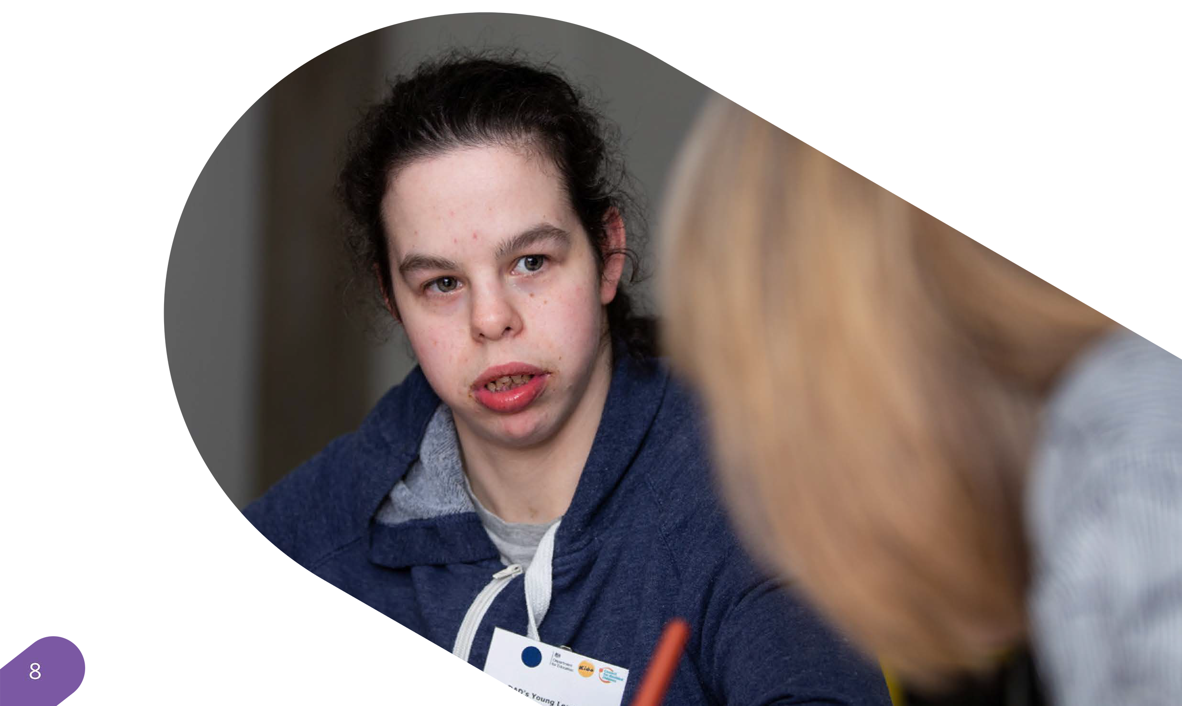If there is anything else you’re concerned about or think we could provide, please let us know. Read the Board’s statement on Diversity, Equity and Inclusion:  
[**https://www.ncb.org.uk/about-us/join-team/our-commitment-diversity-equity-and-inclusion-0/ncb-board-statement-diversity**](https://www.ncb.org.uk/about-us/join-team/our-commitment-diversity-equity-and-inclusion-0/ncb-board-statement-diversity)

# Finance, Risk and Audit Committee

## 

## Purpose

As a sub-committee of the Board, the Finance, Risk and Audit Committee(FRAC) has delegated authority and responsibilities to ensure NCB has appropriate frameworks and controls in place to ensure it operates in a financially sound and prudent manner.

The function of the FRAC falls across three distinct areas:

Financial

* To review annual budgets and forecasts and to recommend them to the Board for approval, and to request action over variances and report any concerns to the Board.
* To ensure NCB integrates financial planning with the wider organisational strategy and management, ensuring that funds and financial resources are available when needed and are used in the most effective way
* To ensure, and where necessary seek assurance, that proper and accurate accounting records are kept and that appropriate accounting procedures and controls are in place

Risk

* To ensure NCB has current and appropriate policies to control and manage key financial and non-financial risks.
* To ensure that periodic, robust risk assessments are carried out to assess risk appetite and that mitigation plans against all major risks, financial and non-financial, are appropriate.

Audit

* To receive, review and agree NCB’s Trustees’ Annual Report and Financial Statements and to recommend them to the Board for approval and formal adoption
* To make recommendations to the Board in relation to the appointment of the external auditors
* To evaluate the work of the external auditor, including assessing their independence, objectivity, effectiveness and value for money

## Key Responsibilities and Duties:

* Ensure effective policies and procedures are in place for managing risk and to assess their effectiveness and to specifically monitor mitigation plans in place against financial risks
* Ensure that NCB complies with all its charitable and financial obligations and requirements and operates in a financially sound and prudent manner;
* To assess and monitor NCB’s long-term financial health and sustainability in-line with the multi-year Strategy.
* To monitor the integrity of the financial statements of NCB, reviewing significant financial reporting issues and judgements contained in them;
* To monitor NCB’s financial performance and report to the Board on significant issues;
* To review NCB’s internal financial controls systems and processes;
* To monitor and review the effectiveness of NCB’s internal audit function (if appointed) or equivalent;
* To make recommendations to the Board on all matters in relation to the external auditor

9

# Person specification

# We are searching for two new Independent Members of the Finance, Risk & Audit Committee who should bring the following essential skills, values and experience to the role:

10

## 

## Skills

* + Ability to clearly present and share complex information or ideas - enhancing the overall competency and technical knowledge of the committee.
  + Excellent communication skills and an ability to persuade and influence to ensure the Finance, Risk and Audit Committee is fulfilling its purpose.
  + Highly collaborative - enjoys and thrives in working within diverse groups and contributing to a variety of discussions.
  + Good listening skills and an openness to other views and feedback on own contribution.
  + Natural problem solver who enjoys exploring creative ways to finding solutions.
  + Ability to offer alternative perspectives, drawing on personal and professional expertise to come up with new ideas and challenge existing thinking.

## Values and ways of working



* + Genuine alignment with NCB‘s mission and values to create better lives for all children and young people.
  + Commitment to upholding high standards of ethics and transparency to NCB‘s governance.
  + Previous Board or committee experience is not essential as we value life experience equally as professional experience; what is essential is your willingness to learn and develop in the role and we will fully support you in this.

## Experience

* The Committee is responsible for both Finance and Risk so we are particularly keen to hear from individuals who:
* Either, have a professional finance background, ideally with a recognised accountancy qualification.
* Or, have professional experience of Risk Management. A professional qualification in this area is not essential.

An understanding of finance and/or risk in the charity sector is desirable but a willingness to learn and the ability to adapt your knowledge to the charity sector is all that is required.

# Additional information

## Time commitment

* + Quarterly Finance, Risk and Audit Committee meetings, held online for 2 hours, typically on a Wednesday afternoon.
  + Committee meeting preparation and follow- up.
  + Engagement in additional, ad-hoc meetings where the need arises. These are exceptional in nature but recent experience is that they may arise a couple of times a year.
  + Engage in the organisational wide work of NCB through learning and knowledge sharing opportunities with staff.
  + We take a blended approach in our ways of working, remotely and in person, so this commitment is accessible and achievable for committee members based across the UK.

# How to apply

# If you wish to apply, please supply the following:

* + - A detailed CV setting out your career history, with responsibilities and achievements.
    - A covering letter (maximum two sides) highlighting your suitability for the role, your motivation for applying, and how you meet the person specification. Please note that the

covering letter is an important part of your application and will be assessed as part of your full application.

* + - Please provide details of two professional referees together with a brief statement of their relationship to you and over what period of time they have known you. Referees will not be contacted without your prior consent.

11

## Role as an ambassador

Trustees and Independent Members are expected to be good ambassadors for the NCB. Their behaviour at all times should enhance and protect the reputation of NCB and all members should take every opportunity to champion NCB and support its activities.

## Remuneration

* All Board roles (including Independent Member positions) are unremunerated, although reasonable expenses will be covered.

* **Application deadline: 9am, Monday 19 May 2025**
* **Interviews: Friday 13 June 2025 (online)**

Please submit your application to: [jobs@ncb.org.uk](mailto:jobs@ncb.org.uk)

Please do also get in touch if you would like an informal chat before applying or if you need any additional support in completing your application.